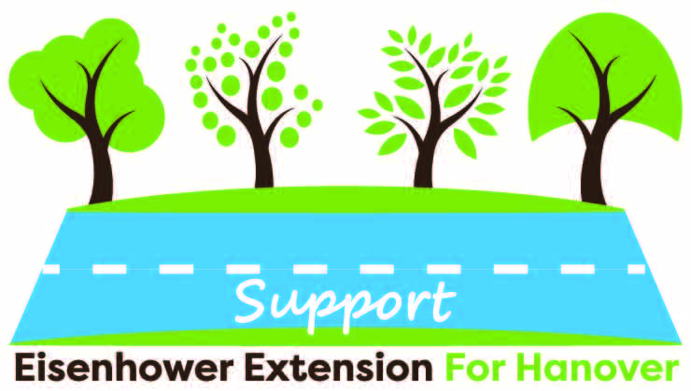

Letters of Support for the Eisenhower Extension for Hanover, PA
How to use the template letter – The Hanover Area Chamber of Commerce and Main Street Hanover have created a letter template to share with the community as inspiration for writing letters of support for the 5C alternative of the Eisenhower Extension. These letters are meant to help community members and business leaders easily and effectively submit letters of support for the project.
Each letter should be put on company letter head, when appropriate, and personalized by the sender. The template contains ideas of reasons for supporting the extension project, but they do not all need to be used in one letter. We encourage the letter writer to personalize this letter. The letters are more impactful when they are unique to each supporter’s situation.
Letters should be sent as soon as possible to PennDOT, but no later than October 1, 2021. Letters should be sent to the address included in the template.
Please spread the word and share this letter and support flyers with others who feel that the Hanover community needs help minimizing traffic congestion and ways to improve the safety of roadways in the area.

